**Lecture 3 – HTML Basic Structure**

* The <!DOCTYPE html> declaration defines that this document is an HTML5 document
* The <html> element is the root element of an HTML page
* The <head> element contains meta information about the HTML page
* The <title> element specifies a title for the HTML page (which is shown in the browser's title bar or in the page's tab)
* The <body> element defines the document's body, and is a container for all the visible contents, such as headings, paragraphs, images, hyperlinks, tables, lists, etc.
* The <h1> element defines a large heading
* The <p> element defines a paragraph

**W3 schools**

**An HTML comment begins with <!** **–– and the comment closes with ––>** .

**HTML Tutorial- Basic Structure of a Website**

After understanding the basics of HTML and the installation of Visual Studio Code, it is now time to understand the **basic structure of a website**. In this tutorial, we will focus only on HTML. Therefore, no need to worry about CSS and JavaScript now.

We have seen earlier, by writing an exclamation mark, we get the whole boiler template of the HTML code. It saves our time as we don't need to write the template code manually. The main reason why we use Visual Studio Code is it allows **code folding (minimize different sections in HTML)** which sometimes becomes necessary to avoid confusion.

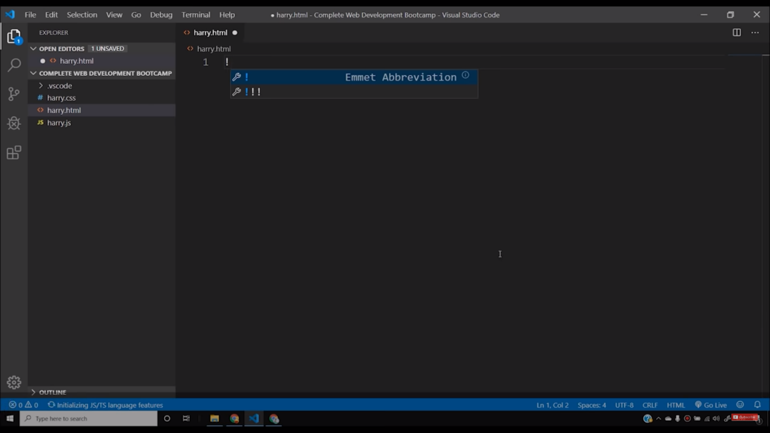

The HTML code contains some sections such as ***DOCTYPE, meta tags, head****,*and***body*.**All the tags that we include in an HTML file, needs to be first opened and then closed by angular brackets*.* Let us now understand different sections one by one.

* **Doctype HTML**- Doctype HTML justifies that it is a HTML document. So, we are defining specifically for a browser to understand that it is an HTML document. To understand more about the type of documents, you can visit [here](https://www.w3.org/International/articles/serving-xhtml/).
* **<html lang= “en”> -**It is the opening part of the HTML tag that tells us the language of the document is in English.
* **<head> -**Head contains all the meta-tags in it which is used to describe the contents of a website. Meta means providing information about information. Therefore, meta tags are used to define the keywords and descriptions on our website. Head also contains the **title**of the website and all the external files like CSS and JavaScript that we link to it.
* **<body> -**Body contains all the contents of the webpage in it.However, in the beginning, our website may look a little uglier but after including stylesheets it will start looking attractive.

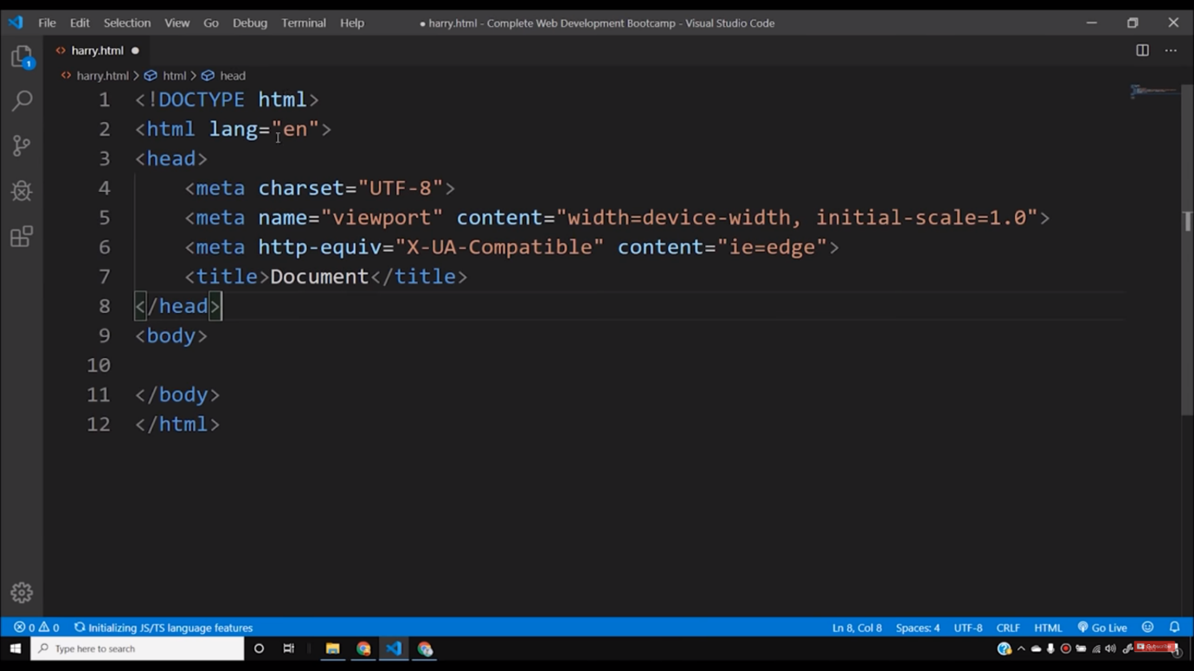

Sometimes we want to write a particular thing that we do not want the browser to take it as a part of code. So, we can include it in the comments by writing **“*<!-- Your text -->”***in this format. However, there is a shortcut to convert any text into comments. You need to press “***Ctrl + /* (forward slash)**” to convert any texts into comments. Comments are completely ignored by the browser and are treated as those parts in the code which the developer writes for his understanding. It is necessary because from time to time our codes will get lengthier and we do not want to mix everything. Therefore, comments become important for reference to anything in the future.

I believe you must have understood until now about how the basic structure of a website looks like. You will not face any type of difficulties if you follow the step by step process as told. Mostly, the coding part will be done under the body section.

And if you have not accessed the playlist till now, I request to go through the playlist because it is the right place where you will find all the videos related to **Web Development in Hindi.**

**Code as described/written in the video**

<!-- This is doctype -->

<!DOCTYPE html>

<!-- Our HTML code starts here -->

<html lang="en">

<!-- Our Head tag starts here -->

<head>

<meta charset="UTF-8">

<meta name="viewport" content="width=device-width, initial-scale=1.0">

<meta http-equiv="X-UA-Compatible" content="ie=edge">

<title>This is title</title>

</head>

<!-- Our Body tag starts here -->

<body>

Yeh meri body ka content hai

</body>

</html>